**Guideline - Followup**

Enter in the Followup vX.Y folder and look for **Followup.exe**

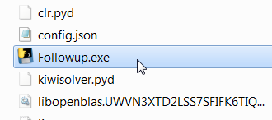

When you will extract the app, working folders are not yet available.

Open the Followup.exe then close the .exe then open it again(for the config.json to be initialized) after that the working folders will be created automatically (one time thing)

Double click on it and wait (**Extract the zip to your PC**)

For the “Followup vX.X execmd.zip” do this:

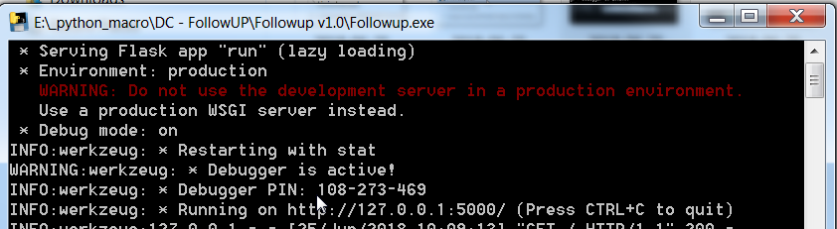

Type/Paste in your **Internet Explorer address bar** this: [**http://127.0.0.1:5000/**](http://127.0.0.1:5000/)

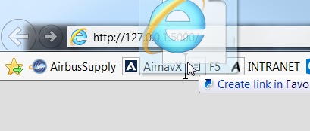

You can Drag and Drop the “E” to make a shortcut.

Wait for the page to load.

For the “Followup vX.Xapp.zip” you will see and interface without the cmd window.

In both cases you can open them in your browser by going to: <http://127.0.0.1:5000/>

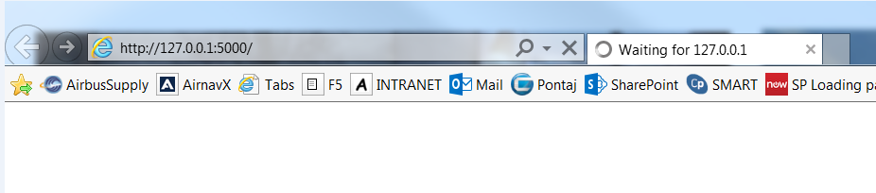

When the page loads you will see a login page.

Enter the credentials provided (defaults are “admin”, “admin” when no user is inserted in the db )

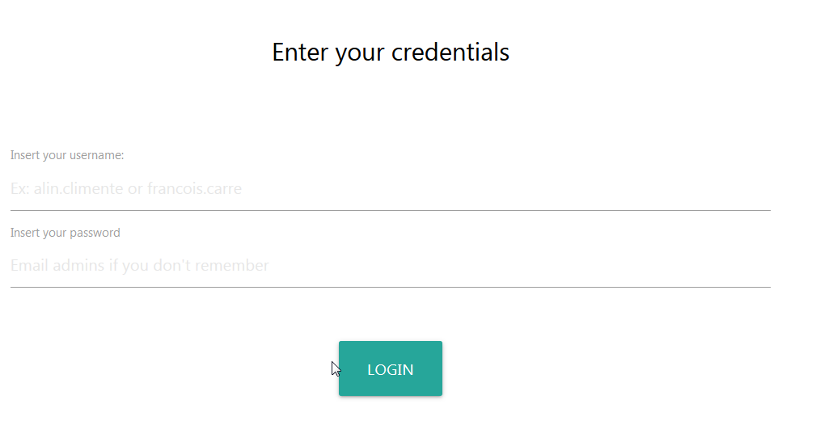

This is the front page where you can: take a new batch, update a batch that you’ve been working on, view the batch status.

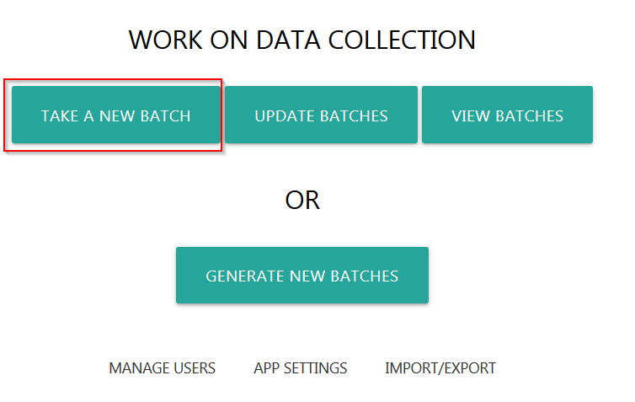

Take a new batch that is unassigned. Click the button to get a batch to work on or (optional) type the batch you want to be assigned to you (a default proofreader will be assigned to you).

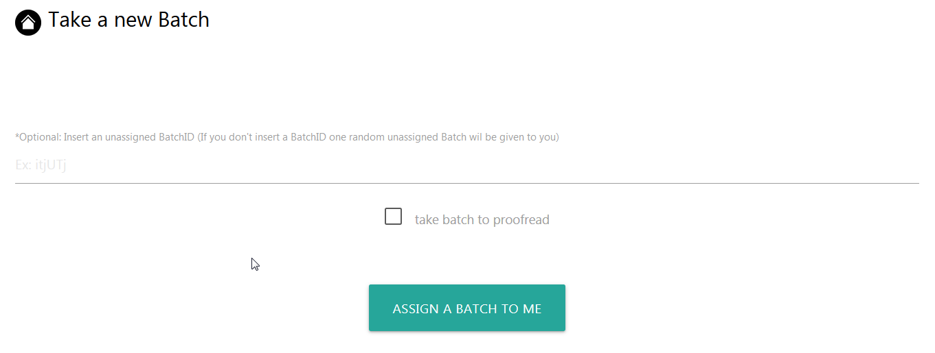

If you are proofreader you can take batch to proofread (the same as mentioned up, type one specific batch or get one unassigned)

On the right down corner of the screen you have a BACK button click on it to go back



Click on home button to go to the main page



Each title next to the home button when cliked will get the latest updates from the database

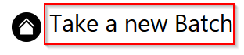

In the **DC BATCHES IN WORK** folder you will have this structure

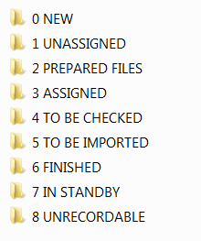

**NEW** – new files from the operator ready to be added in the workflow

**UNASSIGNED** – files from NEW folder added in the workflow (have a BatchID and each file has a FileID prefix)

**PREPARED FILES** – files from UNASSIGNED that are to be prepared for initial processing (extracting initial information – estimated task numbers, estimated findings number...)

**ASSIGNED** – files **moved** from PREPARED FILES that are now processed by a user using Front End macro

**TO BE CHECKED** – files **moved** from ASSIGNED that are processed by the user and need **“**TO BE CHECKED”** by proofreader. (** - this sign on the Update Batches page means that when selecting this status files will be **moved** from one folder to another folder, in this case from ASSIGNED to TO BE CHECKED folder)

**TO BE IMPORTED** – files that are checked by the proofreader and needs to be imported in ISAIM. When the proofreader selects status **“**TO BE IMPORTED”** files from “**TO BE CHECKED”** will be moved to **“TO BE IMPORTED”** folder

**FINISHED** – files that are imported in ISAIM (moved from TO BE IMPORTED folder to FINISHED folder)

**IN STANDBY** – files that come from TO BE CHECKED folder and cannot be worked because there is insuficient information or needs some clarification from the operator.

**UNRECORDABLE** - files that come from TO BE CHECKED folder and cannot be processed.

Below it’s a representation on how files are moved automatically by the Followup app when you to certain operations(change status).

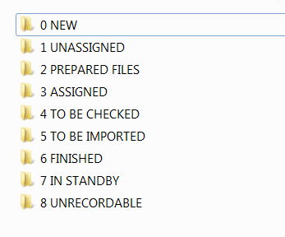

**RED** – when you click on “GENERATE BATCHES” button

**BLUE** – when you click on “ASSIGNED A BATCH TO ME” button

**GREEN** – when you change batch status to “**TO BE CHECKED”

**ORANGE** – when you change batch status to “**TO BE IMPORTED, **FINISHED, **STANDBY, **UNRECORDABLE”

**PURPLE** - when you change batch status to “**REWORK” the files will be moved from TO BE CHECKED folder to ASSIGNED folder.

**NOTE**: if you do an operation that is contrary to the flow of the arrows you will get an error.

**Ex**: Let’s say that you have a batch “IN STANDBY” and you want to change its status to “REWORK” –you will get an error because when you change its status to REWORK the app will look in TO BE CHECKED folder for that batch not in IN STANDBY folder. **To solve this you can move manually the batch from IN STANDBY folder to folder TO BE CHECKED and change the status to REWORK**

**Warning!**

For the Batch Statuses with “**” sign make sure you don’t have any file open!

**TO BE CHECKED, **TO BE IMPORTED, **FINISHED, **REWORK, **STANDBY, **UNRECORDABLE

Update batches as you work on them

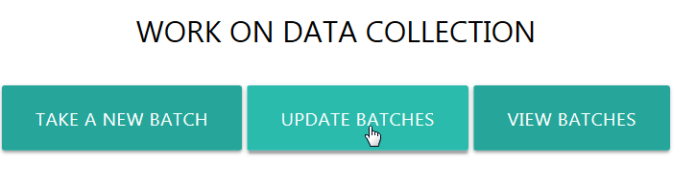

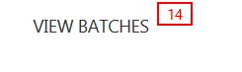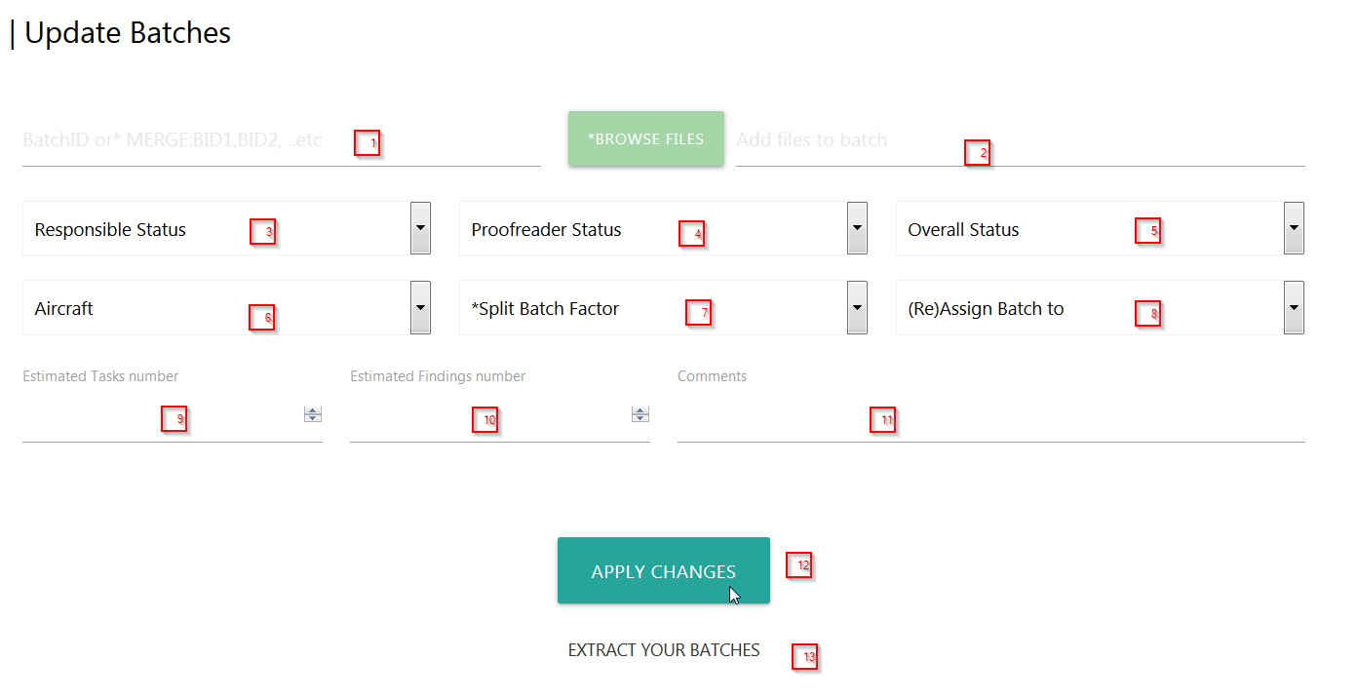

1. Insert the batch ID you want to update (the batch ID is a combination the size of 6 characters which contains letters A to Z, a to z and numbers 0 to 9 like this: **dedD5s**). You can also Merge 2 or more batches by typing them in this input like this: **dedD5s, derdE2, etc**
2. Add more files to an existing **ASSIGNED** batch (browse where you have them)
3. Here as a responsible/user you can change the status of a bach (multiple choises)
4. Here as a proofreader you can change the status of a batch
5. Only proofreaders can change the Overall Status (you can add more statuses in config.json!)
6. Update/Change the Aircraft type if it’s not specified
7. Split batch in more parts (multiple copies of the same batch will be created in the ASSIGNED folder)
8. Proofreaders can reassign the batch to other users
9. Insert the Estimated number of rows(tasks) you’ve imported in Front End macro
10. Insert the Estimated number of Findings you’ve count in Front End macro
11. Write a comment to the Proofreader/user-responsible
12. Execute/apply changes
13. Extract the batches you’ve been assigned
14. Go to VIEW BATCHES page

**View batches from the followup:**

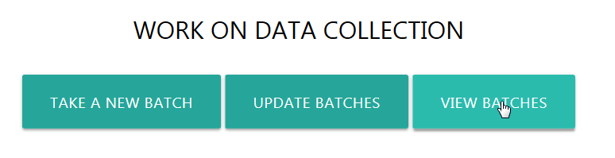

On this page you will have listed all the batches from the followup.

Here you can search for a batch ID and see it’s status/comments and some info

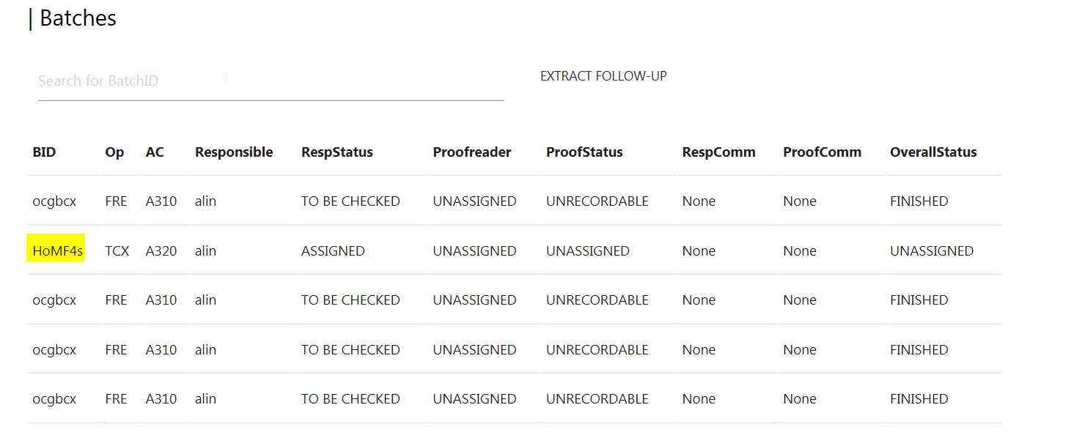

Let’s say that I want **HoMF4s** batch, I will do this:

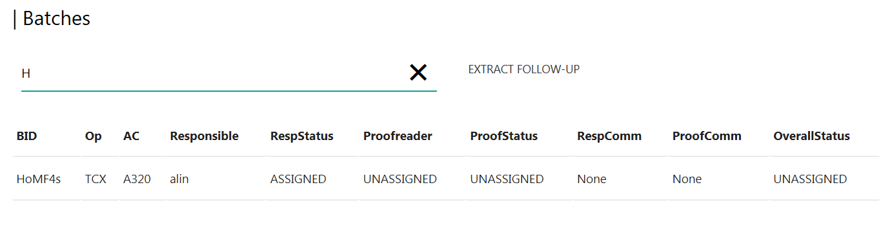

Also, you can click on the BID (BatchID) and you will be redirected to UPDATE BATCHES page with the BID automatically inserted for you to modify.

TIP: On each page to see the modifications you just made or **refresh** the page click on the page title



You can export/import excel tables from the database and investigate them.

You can make big changes on the excel table then import it in the database.

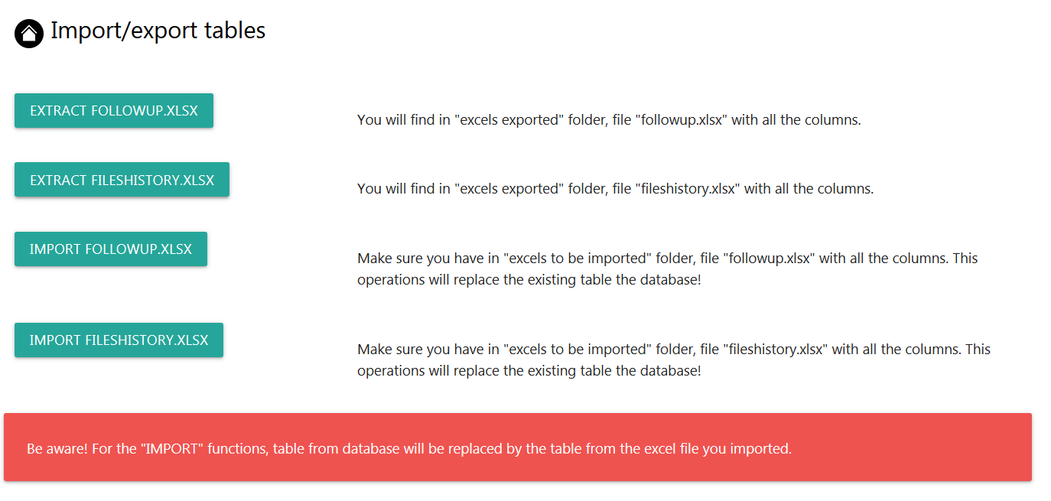

On the App settings page you can see the current settings that the app is running on. If you get some errors send a screenshot of this page to the admins.

Warning: in case of paths changes for each “\” backslash you must add another one (for ‘\’ > ‘\\’)

Bellow values are the defaults, if you delete the config.json file and close the app then open it again if the app doesn’t find config.json file it will create one with the bellow default values.

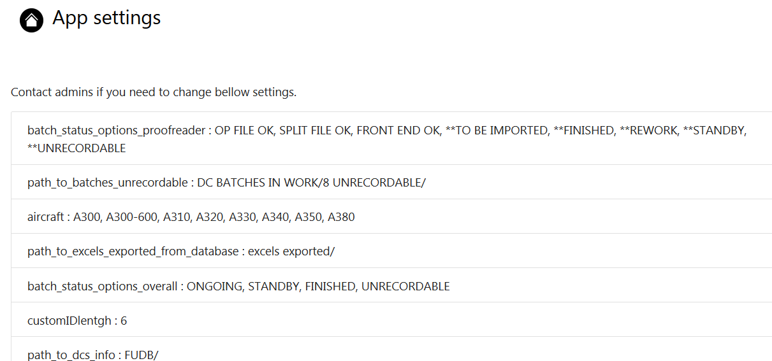

**Make sure you have the config.json file with the paths that point to the sharedrive!**



For safety reasons you must have only one folder with files in 0 NEW folder when you click on GENERATE NEW BATCHES

The folder name must contain this “Operator Aircraft“, like ‘TCX A300’ or ‘TCX 300’

The folder must contain only files, no subfolders!

The reason is that error handling for all the files is not mature enough.

For more than one file you can do this:

* Create a new folder next to 0 NEW
* And move/copy one by one each folder in 0 NEW
* Click on GENERATE NEW BATCHES
* IF THE FOLDER DISSAPEARED FROM ‘0 NEW’ THEN IT’S OK ☺

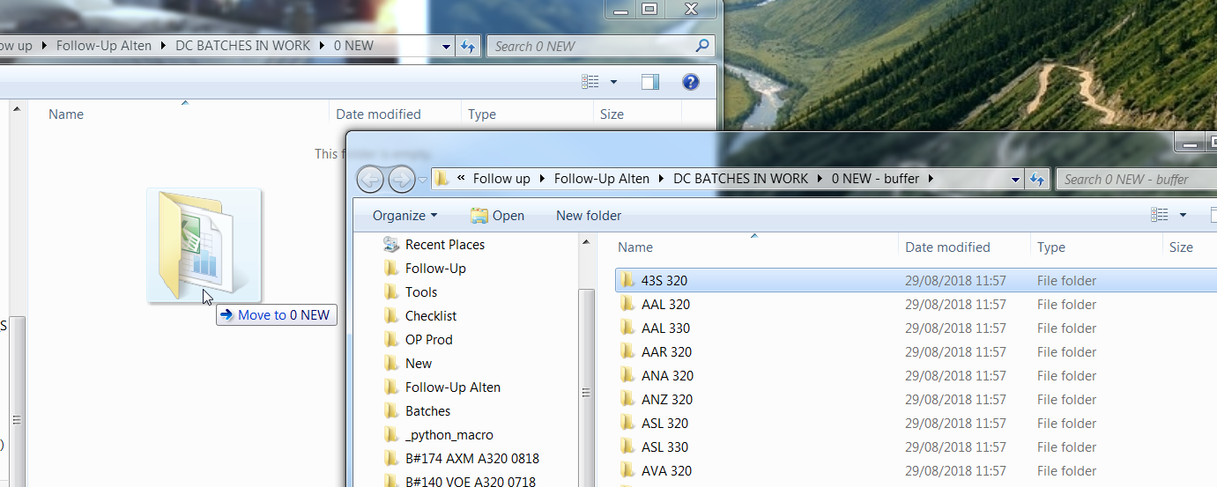

For creation of a new batch when you click on “GENERATE NEW BATCHES” button the app will look in NEW folder and UNASSIGNED folder and find matches between NEW and UNASSG.

If matches are found and the files was not added before then it will be attached to the batch that matched (this will be a match > NEW- BZI 300, UNASSG. – BZI A300 BID_TECEDR).

If there are no matches found then new UNASSG. batches will be created

What happeneds in the background is that the app is combining the Operators name and the Aircraft type to search for folders in "path_to_new_opfiles" > ‘New’ folder if it finds a match will copy the files from the New folder to the unassigned folder and also check if that file was added before by verifing the files history that were added before for file name, file size, file modified date. It will throw an error like bellow if that file was added before.

Example:

In the New folder you have:

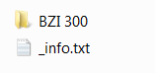

The app will look in New folder for a folder named “BZI A300” or “BZI 300” and copy the files to create a new unassigned batch. If you see green (like bellow) it’s ok.

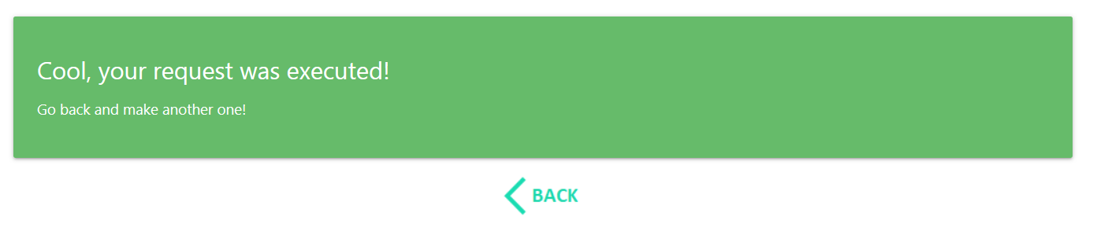

If we try again to create a new batch with the same values and files, you will get something like this:

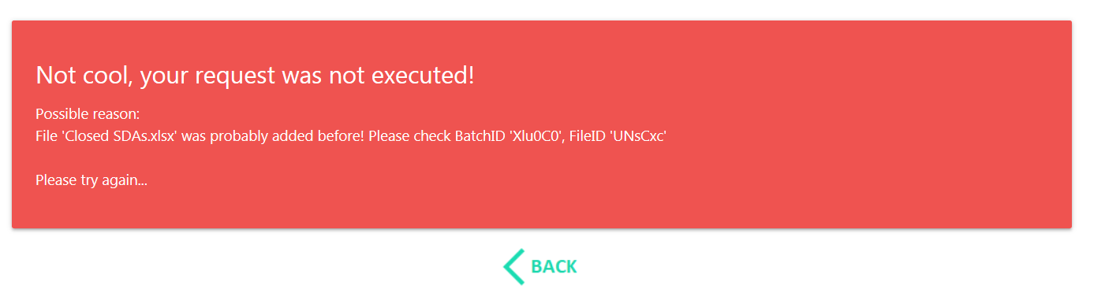

It means that for “BZI 300” the file mentioned in the error was added before. You can check the batch id and the file where this file was added before.

Let’s say that we have **CXD 320**, but is has the same files as BZI 300 that is inserted already.

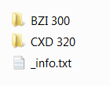

You will get the same error as before

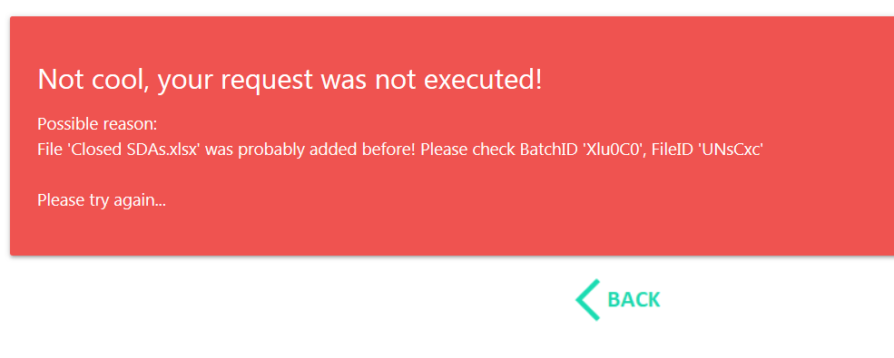

Also if no combination of Operator Aircraft type is found in New folder then you will get this: 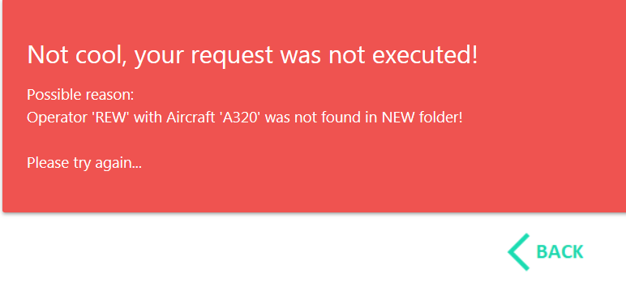

Than means: operator “REW 320” folder was not found in New folder.

Check the "path_to_new_opfiles" setting from config.json file (in the same folder as Followup.exe)

No file is deleted; it’s moved to your local PC in “bin” folder if it can’t move it then it will try to delete it.

The admins can add, remove and modify users that work on Data Collection.

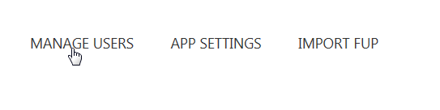

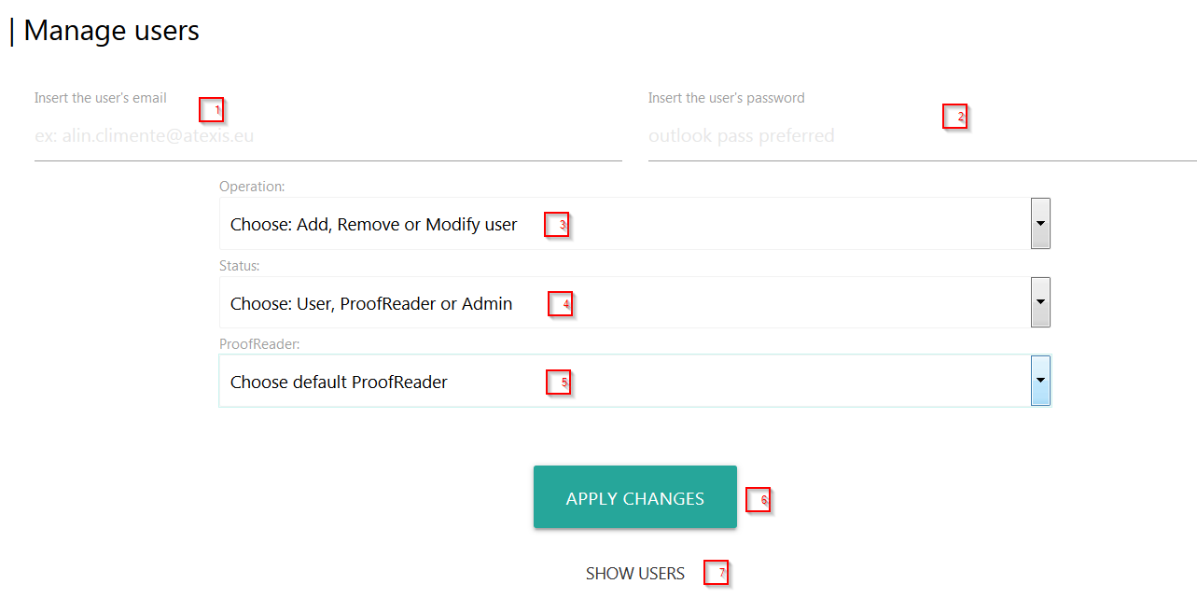

1. Insert the user’s email address or just the username
2. Insert the password that he will use to login
3. 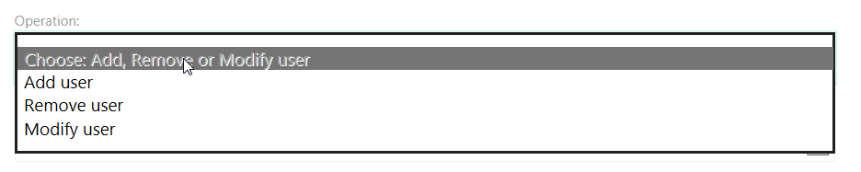
4. 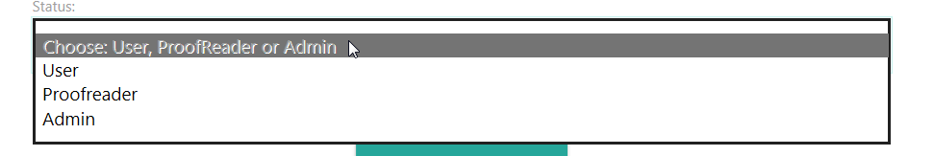
5. 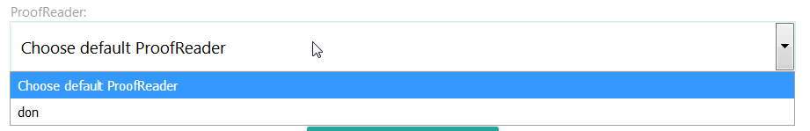
6. Apply modifications/additions you made
7. 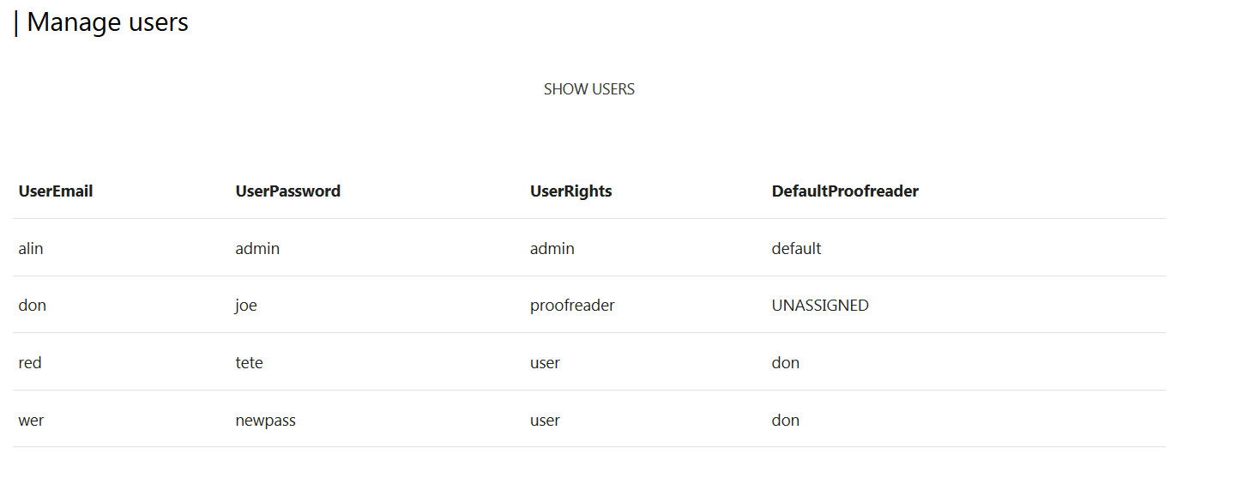

Double click SHOW USERS to see the users table.

**Is a user has multiple rights they must have for each type an different username and password!**

The recommended way of doing this is to name them like:

|  |  |
| --- | --- |
| User: (full name for user type) | francois.carre |
| Proofreader: (short name for proof) | fcarre |
| Admin (shortName – admin ) | fcarre-admin |

To login as user and work on bathces: francois.carre

To login as proofreader and correct users: fcarre

To login as admin and do more: fcarre-admin

**Followup.exe detected as a virus**

One issue that can appear is that the Antivirus can find the exe as a virus..

Don’t worry about this, that’s because the exe extracted doesn’t have a digital signature and the antivirus considers this to be a virus.

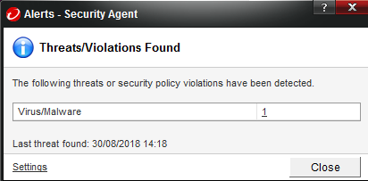

It’s actually a **FALSE-POSITIVE**, because isn’t found in the virus database of the Antivirus and neither in the published software digital signatures so to be sure the Antivirus treats the exe as a virus.

<https://stackoverflow.com/questions/43777106/program-made-with-pyinstaller-now-seen-as-a-trojan-horse-by-avg>

<https://github.com/pyinstaller/pyinstaller/issues/603>

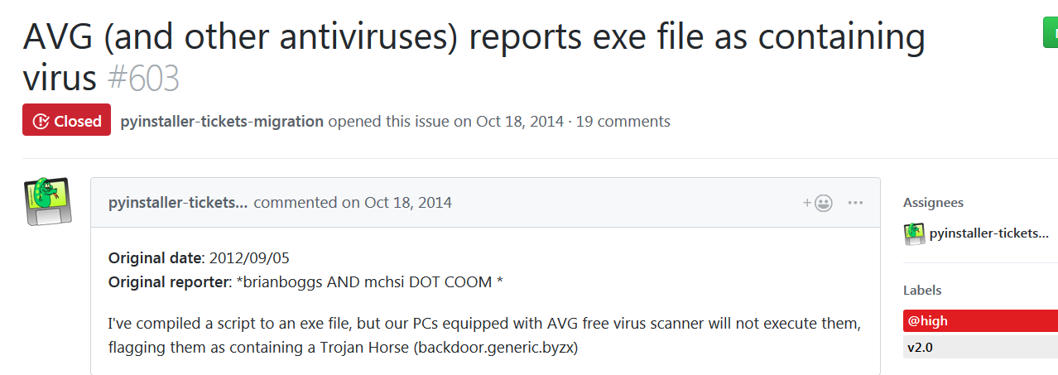

The solution to avoid this can be to:

* **digitally signed the executable** (costs money)
* **install python on your side and run the source code** (you have to manually install dependencies, you must know a little bit python programing language)
* **Add the exe to the exclusion list of the Antivirus (make a tiket to your IT team)**

The last solution is the fastest an simplest way